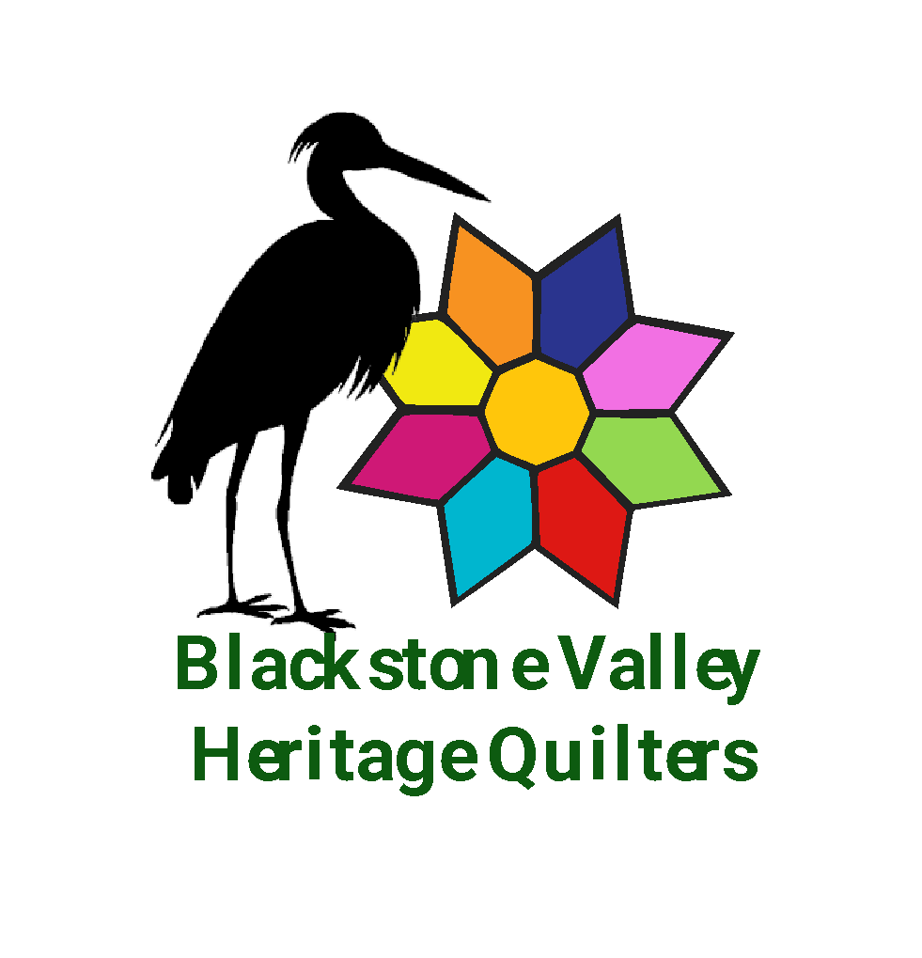

Blackstone Valley Heritage Quilters
New Member Registration
We are so glad you have chosen to join our Guild. We meet monthly, either on the last Wednesday or Saturday of the month from September to June.
Annual membership dues for 2023-2024 are $30.00 for September 1st to July 31st of the following year. Make your dues check out to BVHQ.

Membership benefits include:
- 7 to 8 Educational Programs related to quilting per year (September to June)
- Discount on Educational Hands-on Workshops throughout the year (September to June)
- 10% discount at area quilt shops with BVHQ membership card (year-round)
- Discount on group purchases of patterns or other quilting-related tools
- Access to deeply discounted fabric, tools and patterns in the Treasure Room
- Access to experienced teachers and quilting professionals
⇰ I agree that my name and contact information will be shared with other guild members in a contact list. This contact list will be for BVHQ use only. Initial Here: ____
(Thank you for printing legibly)

Name: _______________________________________________________________________

Street Address: ________________________________________________________________

City, State, Zip Code: ____________________________________________________________

Home Phone _______________________ Cell Phone: ________________________________

Email: ________________________________________________________________________

- - - - - - - - - - - - - - - - - - - - - - - - - - - - - - - - - - - - - - - - - - - - - - - - - - - - - - - -

Internal Use Only: Name: ___________________________ Cash $________Check $_______ # _______

